1. **Launch the URL:** <https://github.com/>
2. Login into Github with the Credentials
3. Open this link https://github.com/bhajojo/RobotFrameworkTraining
4. Click on Button Clone or Download
5. Copy the HTTPs url from the location

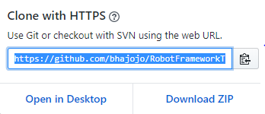

1. Create any Folder on your machine
   1. C:/robotFramewokTraining
2. Open the Command prompt and browse till this location

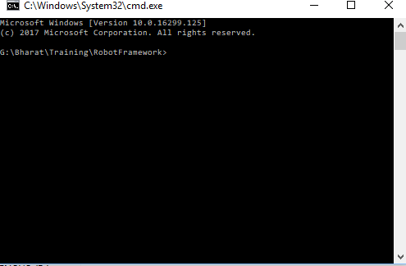

1. Run the command Git Clone and the <https://github.com/bhajojo/RobotFrameworkTraining.git>
2. All the code and all files will be copied on your machine

To make the Changes in the existing repository

1. Make the changes in the existing library
2. Run command
   1. git add .
   2. Git commit -m “Message”
   3. Git pull
   4. Git push